# AI-powered Nutrition Analyzer for Fitness Enthusiasts

**ABSTRACT:**

*Food is essential for human life and has been the concern of many healthcare conventions. Nowadays new dietary assessment and nutrition analysis tools enable more opportunities to help people understand their daily eating habits, exploring nutrition patterns and maintain a healthy diet. Nutritional analysis is the process of determining the nutritional content of food. It is a vital part of analytical chemistry that provides information about the chemical composition, processing, quality control and contamination of food.*

## PROJECT DESCRIPTION:

*The main aim of the project is to build a model which is used for classifying the fruit depends on the different characteristics like color, shape, texture etc. Here the user can capture the images of different fruits and then the image will be sent the trained model. The model analyses the image and detect the nutrition based on the fruits like (Sugar, Fiber, Protein, Calories, etc.).*

## TECHNOLOGIES USED:

*Python, CNN, IBM Cloud, IBM Watson, IBM Cloudant DB, Deep Learning, Python- Flask*

## PROJECT FLOW:

*The user interacts with the UI (User Interface) and give the image as input.*

*Then the input image is then pass to our ﬂask application,*

*And ﬁnally with the help of the model which we build we will classify the result and showcase it on the UI.*

**PROJECT ARCHITECTURE:**

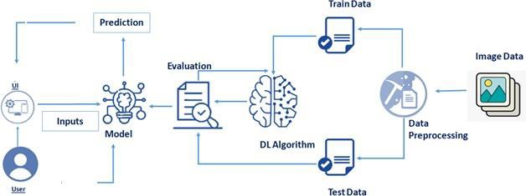

# LITERATURE SURVEY:

Nutrition is vital to the growth of the human body. Nutritional analysis guarantees that the meal meets the appropriate vitamin and mineral requirements, and the examination of nutrition in food aid in understanding the fat proportion, carbohydrate dilution, proteins, ﬁber, sugar, and so on. Another thing to keep in

mind is not to exceed our daily calorie requirements. If this limit is surpassed, we may become fat.

# Deep Food:

Computer-Assisted Nutritional Assessment Using Deep Learning to Recognize Food Images – In order to solve this issue, a brand-new Convolutional Neural Network (CNN)-based food picture identiﬁcation system was created, as described in this study. We utilized our suggested strategy on two sets of actual food picture data (UEC-256 and Food-101).

# Neutrino:

Artiﬁcial Intelligence Nutrition App. As the name implies, the app provides nutrition-based analytics and data to its customers and is quickly becoming a prominent platform for

offering AI ﬁtness services. It deploys predictive analysis for personalized data compilation using mathematical and natural language processing (NLP) models. Furthermore, it shares nutrition-related data with its partners via SDK and API integration to improve its services and product offerings. It Is an Israel-based ﬁrm created in 2011 that allows pregnant women to customize their body’s nutritional requirements. This software collaborated with IBM’s natural language capability to provide 24-hour assistance and dietary recommendations.

**Fitness Time**

App creates a daily food diary for you by recognizing the food from photos you shoot. You take a picture, dial in data such as whether you are eating breakfast or lunch and add a quick text label, and the app estimates the calorie content. It does a pretty good job, although its estimate can be a bit unpredictable. It also needs a network connection, which is something to think about when eating out.

# RESULT AND DISCUSSION:

This model will be useful for every category people irrespective of age and gender.

Using this model we’ll know the exact amount of nutritional content in the food we have which is very useful as it is very important to take care of one’s health.